Scan, Pay, Include: Did UPI Adoption Widen Access to Formal Finance in India?
Udit Chauhan
Pratham Mittal

Abstract

This paper studies how the rollout of the Unified Payments Interface reshaped formal credit usage across 34 Indian states and union territories from 2012–2024. We construct a continuous treatment measure using average pre-UPI deposits per capita from 2012 to 2015 to capture financial readiness and estimate a heterogeneous difference-in-differences model using credit transactions per capita as the outcome. The results document that UPI led to a statistically significant increase in formal credit activity, with substantially larger impacts in states with deeper pre-existing banking systems. A one-standard-deviation increase in deposit exposure corresponds to roughly a 140 percent rise in post-UPI credit transactions relative to the pre-UPI levels, and event-study tests confirm the absence of differential pre-trends. Overall, UPI amplified existing financial depth by improving digital transaction visibility, suggesting that digital infrastructure is more likely to complement rather than substitute traditional financial development.

Introduction
The rapid expansion of India’s digital payments infrastructure has reshaped the financial landscape, with the Unified Payments Interface (UPI) becoming the dominant real-time transfer system. Although UPI was designed for peer-to-peer and retail payments, its adoption may generate broader economic spillovers, including changes in formal credit activity. This paper examines whether states with deeper pre-UPI deposit bases experienced larger increases in credit transactions following UPI’s rollout in 2016.
Our contribution is twofold. First, we exploit continuous variation in financial depth rather than a binary treatment to capture heterogeneous responses to UPI. Second, we use a long state-level panel from 2012–2024, which enables credible identification through fixed effects and a difference-in-differences framework.

Institutional Background: UPI in India
The National Payments Corporation of India (NPCI) introduced UPI, a real-time platform that allows for quick bank-to-bank transfers, in April 2016. Households, businesses, banks, and fintech intermediaries all quickly adopted it, though the rate varied by state based on pre-existing financial depth, internet access, and banking infrastructure.
The central hypothesis is that states with stronger deposit bases prior to 2016 were structurally better positioned to adopt UPI at scale, thereby experiencing larger improvements in formal credit activity.

Contributions

First, we argue that UPI operates as a multiplier of existing financial depth, explaining why states with stronger banking systems benefited more from digital infrastructure. Second, we use a continuous-treatment DID design based on pre-UPI deposits per capita to capture heterogeneous impacts across states. Third, we construct a long state-level panel (2012–2024) combining RBI digital payments statistics, BSR banking data, and population projections. This enables credible parallel-trends testing and a detailed analysis of how digital payments interact with pre-existing banking infrastructure to shape credit outcomes.

Literature Review

Empirical studies show that a reduction in transaction cost can increase consumption, widen formal financial usage, and raise aggregate output (Agarwal et al., 2020; Ouyang, 2022; Sarkisyan, 2023). Analyses with respect to India’s digital public infrastructure bring out how UPI hastened the shift from cash to electronic payments and generated inter-relatedness at the household and firm levels (Dubey and Purnanandam, 2024; Ghosh et al., 2024). A related strand of the literature puts a focus on financial depth, represented by deposit and branch measures along with savings behavior, as a critical modifier of household and firm responses to new financial technologies or policy reforms (Bachas et al., 2021; Dupas et al., 2018; Breza et al., 2024). This set of ﬁndings exhibits important heterogeneity across regions: the preexisting ﬁnancial structure conditions the eﬀects of new ﬁnancial infrastructure. Relatedly, studies focusing on state-level development and ﬁnancial inclusion make it clear that cross-state variation in banking penetration and account use can generate heterogeneous responses to national-level reforms, creating a natural environment to study heterogeneous treatment eﬀects.

Conceptual Framework
UPI’s effect on credit, however, is not uniform across states. Instead, the theoretical prediction is that UPI amplifies the existing level of financial depth in each region. The mechanism linking UPI adoption to credit expansion operates through three channels.

Digital Payments and Information Generation
UPI creates verifiable digital payment trails at zero cost, thereby facilitating access to finance for borrowers devoid of collateral or formal credit histories. Where banking penetration was deeper before UPI, the take-up rate boosts digital transactions and speeds up information generation for lenders. Credit supply expands more strongly in states with higher prior formal banking engagement.

UPI as a Multiplier of Financial Depth
From a theoretical standpoint, UPI acts not as a stand-alone credit intervention but as a multiplier of existing financial development. States with weak banking penetration, low deposits, and limited branch presence benefit less because the digital infrastructure alone cannot substitute for the absence of formal accounts. In contrast, high-exposure states experience an acceleration in credit allocation, as digital payments lower information asymmetry and allow lenders to reach new borrowers.
The conceptual framework, therefore, suggests that UPI strengthens the link between financial access and financial usage. It deepens credit markets most effectively in states where the preconditions for digital adoption like bank accounts, savings behavior, financial literacy, and physical banking infrastructure were already in place. This theoretical prediction is consistent with the empirical results presented in Section 7.

Data
This study uses an unbalanced panel dataset of 34 Indian states and union territories covering the period 2012–2024. The dataset is constructed from three primary sources:
(i) Reserve Bank of India (RBI) digital payments statistics, (ii) IndiaStat, (iii) Census and state population projection data, (iv) RBI Basic Statistical Returns (BSR).
The key outcome variable is credit transactions per capita, computed by dividing the total number of credit transactions recorded in the RBI digital payments database by each state’s annual population. This measure captures the intensity of formal credit usage and enables meaningful comparison across states of different sizes. All monetary values are normalized per capita to make states comparable.

Treatment Variable: Pre-UPI Deposit Exposure
The main treatment variable is a continuous measure of each state’s financial readiness prior to UPI. We construct deposit exposure as the average deposits per capita during 2012–2015 (the entire pre-UPI period). Deposits per capita serve as a proxy for financial depth: states with higher values exhibit greater savings activity, more active bank accounts, and deeper engagement with formal banking channels.

Control Variables
To account for differences in formal financial infrastructure, we include the number of new bank branches opened in each state each year. A larger banking footprint may drive credit activity independently, and controlling for it helps isolate UPI's impact on credit. The population data are used only for normalization of transaction counts and not included as extra controls.

Distribution of Exposure
Figure 2 in the Appendix shows a right-skewed distribution of pre-UPI deposit exposure, with most states clustered below ₹100,000 and a long upper tail. This reflects uneven financial development, where only a few advanced states exhibit deep banking penetration. The wide dispersion provides strong treatment variation, enabling credible estimation of heterogeneous effects.

Summary Statistics
This section presents the descriptive statistics of the key variables used in the analysis. The dataset consists of 442 state-year observations from 34 States and Union Territories for the period 2012–2024.

Table 1: Summary Statistics

Variable | Obs | Mean | Std. Dev. | Min | Max
creditpc | 442 | 0.0113583 | 0.025812 | 0.0003988 | 0.228264
debitpc | 442 | 0.0180362 | 0.0424628 | 0.0013419 | 0.4566126
bbpc | 442 | 0.0079655 | 0.0087542 | 0 | 0.1396887
population | 442 | 3.60e+07 | 4.39e+07 | 64,429 | 2.00e+08

The variables exhibit substantial variation across states and over time, reflecting
differences in financial development, demographic size, and banking penetration. Credit and deposit measures vary widely, indicating heterogeneity in financial activity across the Indian states, while population differences highlight the scale asymmetry between smaller UTs and larger states.

Treatment: Pre-UPI Deposit Exposure
Our treatment variable is a continuous measure of UPI exposure defined as the average deposits per capita in each state during the pre-UPI period (2012–2015). Formally,
$$\text{Exposur}{\text{e}}_{\text{s}}\text{=}\left(\text{1}/\text{4}\right)\text{*}\sum_{\text{t}\text{=2012}}^{\text{2015}}{\text{DepositsPerCapit}{\text{a}}_{\text{st}}}$$
This variable captures the financial depth of each state before the introduction of UPI. Given that UPI requires active banking accounts of users on the platform, higher levels of deposits per capita imply a larger section of the population was already connected to the formal banking system. This makes exposure a natural predictor for the intensity of UPI adoption. States with a stronger deposit base before UPI were well-placed to adopt digital payments quickly because:
- Deposits reflect the extent of everyday banking activity,

- Higher deposits suggest higher formal financial participation.

- UPI requires money stored in bank accounts.

- States with deeper banking networks could adopt UPI faster after 2016.

Therefore, pre-UPI deposit exposure is a meaningful way to measure how digitally ready a state was prior to the rollout of UPI.

Empirical Strategy
Our empirical objective is to estimate whether the introduction of UPI in 2016 caused a differential increase in formal credit activity across states with varying levels of pre-existing financial depth. Financial depth is measured using the average deposits per capita in the years prior to UPI (2012–2015), which we treat as a continuous exposure variable. This captures the fact that UPI adoption is not a binary treatment but rather a shock whose effects scale with the underlying financial readiness of each state.

Why a Continuous Treatment?
UPI was launched nationally in 2016, so states did not differ in timing of treatment; instead, adoption intensity depended on pre-existing financial development. These characteristics determined how effectively UPI could translate into financial access gains. States with higher deposit exposure are therefore expected to experience stronger post-UPI credit responses. A continuous DID framework captures this heterogeneity in treatment intensity.

OLS Baseline Specification
Before estimating the causal effects, we also consider the unconditional relationship be- tween financial depth and credit levels using the following model:

Y_{st} = θTreat_{s} + δ_{t} + µ_{st}. (1)

This specification excludes post-UPI interactions and captures only the cross-sectional association between deposits and credit, reflecting that financially deeper states already had higher credit levels. We use this as a baseline to show that high-exposure states started from a stronger credit position. The DID model then identifies the additional post-UPI change beyond this pre-existing relationship.

Main DID Specification
Our primary estimating equation is a heterogeneous difference-in-differences model:

Y_{st} = β₁(Treat_{s} × Post_{t}) + γX_{st} + α_{s} + δ_{t} + ϵ_{st}, (2)

where:

- Y_{st} is the credit per capita in state s at time t,

- Treat_{s} is the continuous exposure measure (average deposits per capita in 2012– 2016), Post_{t} is a post-UPI dummy equal to 1 for t ≥ 2016,

- X_{st} includes the number of bank branches opened each year,

- α_{s} are state fixed effects capturing time-invariant characteristics such as banking culture or baseline development,
- δ_{t} are year fixed effects capturing national shocks such as macroeconomic cycles or regulatory changes.
The coefficient of interest is β₁, which measures how much additional credit growth occurred in high-exposure states relative to low-exposure states after UPI.
A positive and statistically significant β₁ implies that UPI scaled more effectively in financially mature states, consistent with the theoretical mechanisms described earlier.
Standard errors are clustered at the state level to allow for arbitrary serial correlation within states over time, following standard practice in panel-data DID designs.

Interpretation of the DID Coefficient
Because the treatment is continuous, β₁ does not represent an average treatment effect but instead the marginal impact of greater financial depth on post-UPI credit growth. It measures how much more credit per capita increased after UPI in states with higher pre-UPI deposits per capita.

Identification and Assumptions
The key assumption for identification is a parallel trends assumption: in the absence of UPI, states with high and low pre-UPI deposit exposure would have continued along similar credit trajectories. We validate this using an event-study specification, showing that pre-2016 differences in credit growth between high- and low-exposure states are small and statistically insignificant. Figure 1 in the Appendix shows parallel trends.

Results

OLS and DID Estimates

Table 2: Regression Results: Exposure, DID Models, and Controls

 | (1) Exposure OLS | (2) DID: State + Year FE | (3) DID: State FE Only | (4) DID + Bank Branches
Exposure | 1.2811∗∗∗ (0.0990)
DID |  | 0.4109∗∗  (0.1675) | 0.3861∗∗∗  (0.1333) | 0.3909∗∗  (0.1510)
Bank branches |  |  |  | included
Year FE | No | Yes | No | Yes
State FE | No | Yes | Yes | Yes
Observations | 442 | 442 | 442 | 442
R-squared (within) | 0.2756 | 0.6038 | 0.0483 | 0.6046
Standard errors in parentheses. ∗∗∗p < 0.01, ∗∗p < 0.05, ∗p < 0.1. Model (1): unconditional exposure model. Model (2): DID with state & year FE. Model (3): state FE only. Model
(4): DID with bank branches as a control.

Table 2 reports four regression specifications examining how pre-UPI financial exposure shaped the credit response following the introduction of UPI. Model (1) presents the unconditional cross-sectional relationship, while Models (2) – (4) progressively incorporate fixed effects and additional controls to strengthen causal interpretation.
In Model (1), pre-UPI deposit exposure is strongly and positively associated with credit per capita (β = 1.2811, p < 0.01). This indicates that financially mature states are those with deeper formal banking penetration prior to 2016 which naturally exhibited higher credit levels.
Model (2) introduces both year and state fixed effects and includes the continuous Difference-in-Differences (DID) interaction term. The coefficient of the DID variable is positive and statistically significant (β = 0.4109, p < 0.05), implying that, after the introduction of UPI, states with greater pre-UPI exposure witnessed disproportionately larger increases in per capita credit. This specification controls for time-invariant state characteristics and common macroeconomic shocks, enhancing causal credibility. Model (3) has only state fixed effects and renders a larger and highly significant DID coefficient (β = 0.3861, p < 0.01). The pattern shown here suggests that, if cross-state heterogeneity is the only factor controlled, the estimated impact of UPI strengthens, indicating substantive variation in the timing and magnitude of credit growth. Model 4 adds the number of bank branches per capita as a control to further capture complementary financial infrastructure. The DID estimate remains positive and statistically significant at β = 0.3909 (p = 0.034), with an overall high R² within the model of 0.6046.
Taken together, the four models consistently show that UPI disproportionately accelerated credit growth in states that were more financially prepared prior to its introduction. The results herein presented support the interpretation that UPI is a multiplier of existing financial depth, thereby allowing a faster and wider credit expansion in states with a more robust pre-existing formal banking ecosystem.

Economic Significance
To interpret the magnitude of the effects, we convert the coefficients into economically meaningful changes. A one standard deviation increase in pre-UPI deposit exposure (0.042 on the dr variable) implies an additional increase of approximately 0.042 × 0.39 ≈
0.016 credit transactions per capita after 2016.
Relative to the pre-UPI mean of 0.0113, this represents an increase of nearly 140 percent. Though the numbers are small, controlling for population, they do indicate that UPI significantly expanded formal credit activity in financially developed states. In other words, digital payments infrastructure doesn't level the playing field across states; it grows more where the financial system is already ready-where bank accounts are common and deposits already flow-yielding bigger benefits there.

Robustness Checks
We implement a series of robustness exercises to verify that the results are not driven by modelling choices or outlier states.

Alternative Exposure Measures
We re-estimate the DID model using two alternative constructions of exposure: (i) median deposits per capita during 2012–2015, and (ii) log deposits per capita. In both cases, the DID coefficients remain positive and statistically significant, indicating that the findings are not sensitive to how financial depth is measured.

Placebo UPI Introduction
To ensure the results do not arise from coincidental differential trends, we assign a placebo UPI launch year of 2014 and re-estimate the DID model. The placebo interaction term is small and statistically insignificant, confirming that the observed post-2016 effects are not present in pre-UPI years.

Dropping Outlier States
We drop high-exposure outliers (Maharashtra, Karnataka, and Delhi) one at a time and jointly. The DID coefficients remain stable across specifications, suggesting that the treated–control gradient is not dominated by a few financially advanced states.

Pre-Trend Slope Comparison
We compute pre-2016 linear trends in credit per capita separately for high and low exposure states. The difference in slopes is statistically indistinguishable from zero, providing an additional diagnostic supporting the parallel trends assumption.

Conclusion

This paper shows that UPI did not boost credit equally across India. Using state-level data from 2012 to 2024, we find that UPI mainly strengthened states that were already financially developed. States with higher deposits before 2016 saw much larger increases in credit after UPI, with effects of roughly 140 percent relative to pre-UPI levels. Event-study tests and robustness checks confirm that these results are stable.
States with weak access to banking benefited very little, indicating that digital payments per se cannot replace basic financial infrastructure. Expanding account ownership, savings activity, and branch networks remains fundamental.
Fundamentally, UPI works best when strong financial foundations are already in place. Further research at the micro level can discuss how digital histories of transactions affect lending decisions.

Policy Implications
The results indicate that UPI provides the greatest benefit in states with good pre-existing financial depth, and there is, therefore, a need for complementary inclusion policies in lagging regions. Expanding Business Correspondents, improving digital literacy and onboarding, and strengthening basic banking infrastructure can provide the means for low-depth states to begin building deposits, regular digital transactions, and the resultant payment histories that are required for credit assessment to ensure that UPI-driven credit growth reaches hitherto unserved areas rather than expanding disparities across states.

References

Agarwal, A., et al. (2017). Do bank accounts boost savings and consumption? Working Paper.
Agarwal, S., Ghosh, P., & Ghosh, S. (2020). Digital payments and household consumption: Evidence from India. Working Paper.
Alok, Shashwat and Ghosh, Pulak and Kulkarni, Nirupama and Puri, Manju, Breaking Barriers to Financial Access: Cross-Platform Digital Payments and Credit Markets (April 14, 2024). Indian School of Business WP Forthcoming.
Bachas, P., Gertler, P., Higgins, S., & Seira, E. (2021). Banking on the poor: Savings, poverty, and financial inclusion. American Economic Review, 111(1), 1–47.
Balyuk, T., Prabhala, N., & Bachmann, R. (2022). FinTech lending, credit access, and financial inclusion. Journal of Financial Economics.
Bartlett, R., Morse, A., Stanton, R., & Wallace, N. (2022). Consumer-lending discrimi- nation in the FinTech era. Journal of Financial Economics, 143(1), 30–56.
Berg, T., Fuster, A., Thesmar, D., Vickery, J., et al. (2022). FinTech and the future of finance. Annual Review of Financial Economics, 14, 153–178.
Breza, E., Kanz, M., & Kuhnen, C. (2024). Financial access and long-run household outcomes. Quarterly Journal of Economics.
Chioda, L., et al. (2024). FinTech credit and household outcomes. Working Paper.
Dubey, P., & Purnanandam, A. (2024). Digital public infrastructure and economic out- comes: Evidence from UPI. Working Paper.
Dupas, P., Karlan, D., Robinson, J., & Ubfal, D. (2018). Banking the unbanked? Evidence from three countries. American Economic Review, 108(2), 436–474.
The Economic Times. (2023). UPI as a model for global digital public infrastructure. Yadav, A. (2024). Remarks on digital payments and public infrastructure. Federal Reserve Speech.
Fuster, A., Goldsmith-Pinkham, P., Ramadorai, T., & Walther, A. (2019). The role of technology in mortgage lending. Review of Financial Studies, 32(5), 1854–1899.
Gates, B. (2020). India’s digital payment revolution. The Indian Express.
Gopal, M., & Schnabl, P. (2022). FinTech, credit, and labor market power. Working Paper.
Kalda, A., & Neshat, M. (2024). Behavioral factors in digital lending. Review of Finance. Kanz, M. (2016). Credit access and information frictions: Experimental evidence. American Economic Review, 106(4), 737–772.
Ouyang, M. (2022). Cashless payments and economic activity. Journal of Monetary Economics.

Appendix

Parallel Trends
To validate the Difference-in-Differences design, we estimate the event-study specification and plot dynamic treatment effects around the rollout of UPI. Figure 1 shows that the pre-treatment coefficients are small and statistically indistinguishable from zero.
We also conduct a joint F-test on the pre-UPI event-study coefficients to assess whether they are jointly different from zero. The null hypothesis of parallel pre-trends cannot be rejected (p = 0.42), confirming that high- and low-exposure states evolved similarly before 2016. This strengthens the validity of the identification strategy and ensures that post-2016 divergences can reasonably be attributed to the introduction of UPI

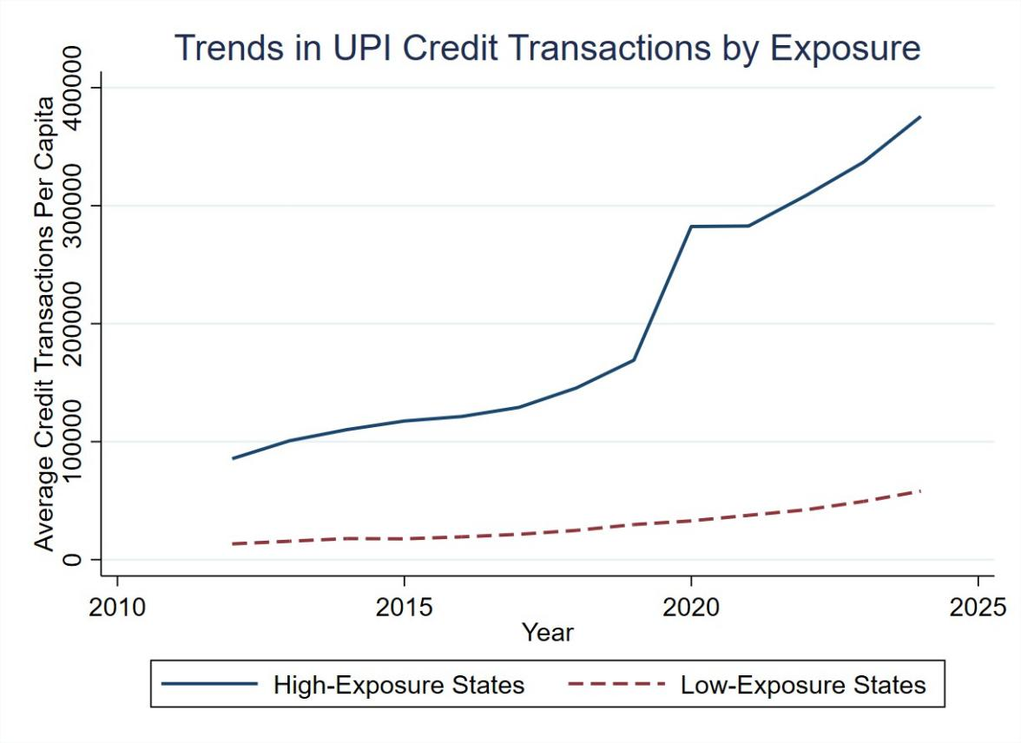
Figure 1: Parallel trends between high and low exposure states. The pre-treatment trends move in the same direction with comparable slopes, supporting the DID assumption of parallel pre-treatment trajectories. We have adjusted the credit per capita by multiplying it by 100000 so that the graph is clear visually.

Density of Exposure

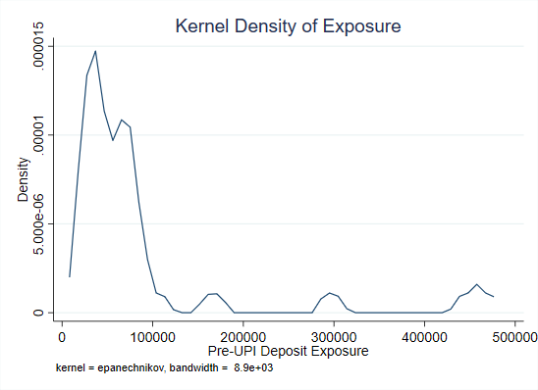
Figure 2: Kernel Density of Pre-UPI Deposit Exposure

Overall, the data reveal substantial pre-existing heterogeneity in financial depth, supporting the use of a continuous DID framework in our empirical strategy.

